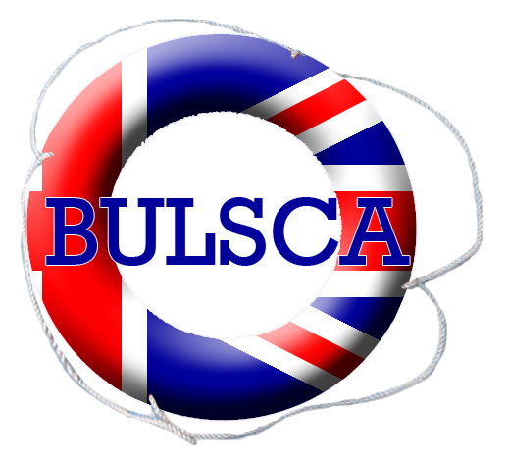
British Universities
Life Saving Clubs’ Association

Feedback Form

BULSCA National Student Championships
21st & 22nd March 2009
Olympos, Burgess Hill

Thank you to all for their competitive spirit, enthusiasm and officiating support throughout the whole weekend. Without this the Championships would not have gone so smoothly.
It would be really helpful for the delivery of future events if we could have your feedback, so please take a few moments to complete the following questions.

General
 | Strongly agree | Agree | Disagree | Strongly disagree
Pool & facilities were good
Enough information before the event
Enough information during the event
Accommodation space provided was good
Food provided was good
Food provided was good value for money
There were lots of opportunities to ask questions throughout the event.
Additional and overall comments of the weekend

Saturday
 | Strongly agree | Agree | Disagree | Strongly disagree
Registration was efficient, long enough and provided enough information.
Order of events and their delivery was good
Quality of marshalling was good.
Quality of officiating was good.
Presentations of speeds were good.
Additional comments

Sunday
 | Strongly agree | Agree | Disagree | Strongly disagree
Registration was efficient, and provided enough information.
Order of events and their delivery was good.
Quality of marshalling was good.
Quality of officiating was good.
Information provided during the event was good.
Presentation of awards were good.
Additional comments

Helpers & officials
 | Strongly agree |  | Agree | Disagree | Strongly disagree
Good balance of roles through the weekend.
Good level of information provided before the event.
Enough information was provided during the event.
Refreshments provided were good.
Clear briefs from the person you were responsible to.
The weekend was enjoyable.
Would you support the Championships next year? |  | Yes |  | No
If no, why not?
Overall and additional comments

Thank you for your time in completing this feedback form.
Please return to championships@bulsca.co.uk

